
Maize Analytics

In-Depth Analytics Guide

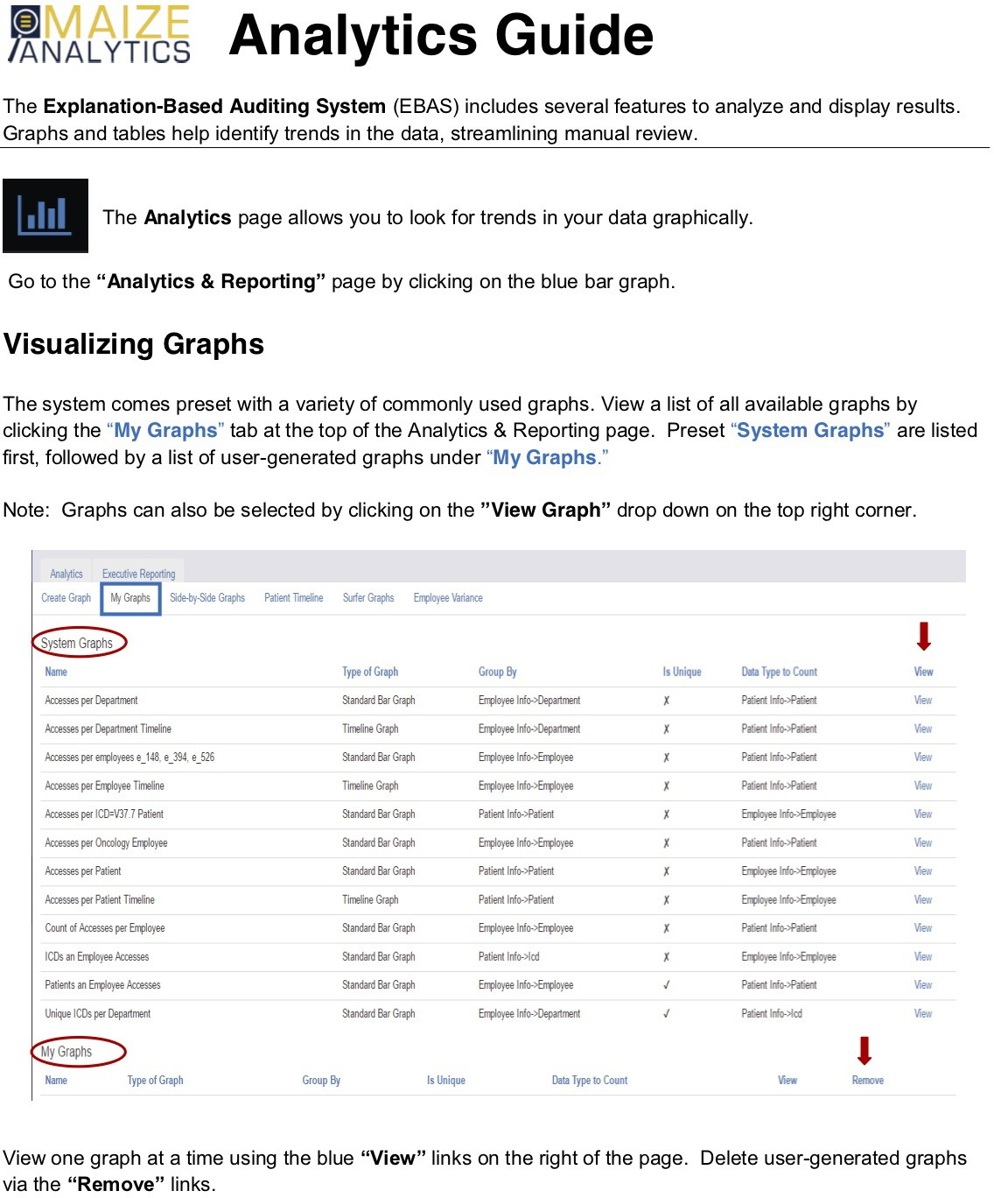

- To visually compare graphs, click the"Side-by-Side Graphs" tab at the top of the page. Specify two graphs to compare, and click the blue"View Graphs" button.

Ma/)1,cs
Creale Graph

ExeartrwReport„m..,g _
Mi Grapł,, Side-by-Side Grarm
I
I

PotientTmefm &der Grap/\5 oiee\lariana,

Side-by-Side Graphs
Use!lis pag• 10 """ i-.,, graplis sidel,y-<ide,11iiich can be u„fo for tasks such as ooniiamg clfferant """ period,
Graph I start dale
mrn/dd/yyyy
Graph I end date
mrn/dd/yyyy
Graph 2 start dale
mmjdd/yyyy
Graph 2 end date
rrm/dd/yyyy
- Graph and TableDisplay OpHons

Graph 1 •
Select a g@l)n...

Graph 2•
Select a graph...

Select type
......
Upload source•
•All u•ploads

Optional: Limit the accesses shown on both graphs by specifying dale ranges or using the "Select type"dropdown menu. Select type will limit displayed accesses to a parlicular type of record.
- Click the"Patient Timeline" tab at the top of the Analytics & Reporting page to display accesses to a single patient's record (e.g. Alice) in clickable timeline form.

Analytics Create Graph
Executive Reporting
My Graph.s Side-by-Side Graph.s IPatient Timeline
I

Surfer Graph.s Employee Variance

Patient l7meline
The timeline visualizes the events occurring to treat the patienL Accesse.s are grouped by department

Blue boxes represent encounters, green. boxes represent e)(plained accesses. a nc:I red Doxes represent unexplained accesses_

Patient" Start date
.. End date
ALICE
O 1/01/2015 06/20/2016

,
Access: Olher Appointment Medic.;:ition

Upload source"'

■ ■

All uploads

2015-01 2015-0!i 201!io-OJ 2015--09 2015-11 2016-01 2016--03 201!!-05

Note: Blue boxes represent encounters, green boxes represent explained accesses, and red boxes represent unexplained accesses. Clicking on a box displays the event(s) represented by that co/or in the "Search" page (see following).
,t, Maize Analytics 2

Show entries
a

eiect!J'l.acce:H , _,_J llale/Time PalienllD PatientNlll'Tlł! Emp.lD Emp.Nam, Emp.llepllllrnenl Souiu Ro

t, m Ol-011200:00 ALJCE NANCY PEDIATRICSłlURSING EPICIIYCHAIU lłURSłłG
I l
a�• I°
  - I° 2QII-G1-01l1:00'IO ALJCE NANCY PEDIATRICSłlURSllłG EPICIIYCHAIU lłlJRSłłG
a
-
I> • I° 2011-Gl-0111:00-GII ALJCE NANCY PEDIATRICSłlURSllłG EPICIIYCHAIU lłURSłłG
C 1
.--

- Click the"Surfer Graphs" tab at the top of the Analytics & Reporting page to display potentia! inappropriate access.

Analytics Create Graph
Exeaitive Reporting

My Graphs Side-by-Side Graphs Patient 11meline Surfer Graphs Employee Variance

"Surfer" is a term we use to describe an employee who is the only person who accessed a particular patient's medical records. Often these are benign, but could also indicate a malicious user who "surfs" around on patients' medical records. Surfing Rate is the ratio of surfer accesses to the employee's total patients accessed.
Specify a date range or data source to search by clicking the"Graph Search Options" bar.

  - Graph Search Options

Date range
0l/02/2000 • 02/02/2015

Upload source*
All uploads

Update Graph/Table

- Click the"Surfer Graphs" tab to view graphs of employees who solely accessed patient records. You can visually identify employees with higher numbers of surfing accesses.
- Use the gray handles on the Surfer Accesses and Surfing Rate graphs to adjust the shaded region. This will specify a number of patient record accesses or range of surfing rates to view.

Surfer Accesses
-++
Adjust shaded regions (i\
\V
using the gray handles

Surfing Ra e
-++
CD
◄o 50 eoo o

Surfing rate indicates the ratio of surfer access to the employee's lota/ patients accessed. Higher surfing rates indicate mare surfing activity.
t) Maize Analytics 3

- Scroll down to the"Top Surfer Employees" table and click on a specific employee to review their access log. In the table, employees are listed in descending order of surfer accesses.
- Review access logs of high variance employees by clicking on the employee name.

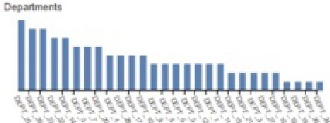

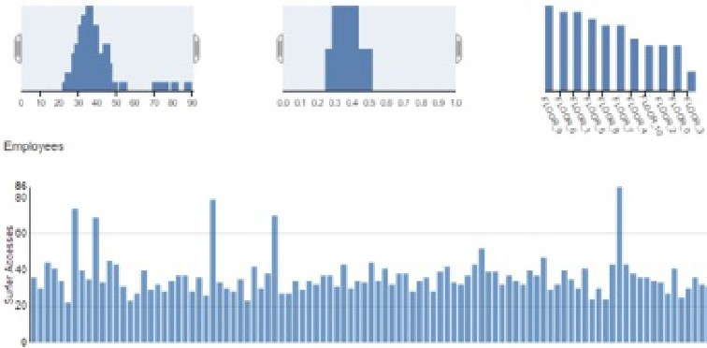
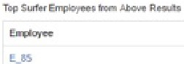
10Dd100
- Grapłise;wi::h
_,,,...

...,,  ...,, | OEPT_1D | "-"""-'  FLOOA_a,  FlOOILO
 |  | Fl""'L>
'-" | OEPT_O | "OOIL'  F\,OQR_i,.

- Click the"Employee Variance" tab at the top of the Analytics & Reporting page to display high variance employees.

P..nalytics Create Graph

Executive Reporting
I
My Graphs Side-by-Side Graphs Patient Timeline Suńer Graphs
Employee Variance I

Employees who access an atypical number of patient records based on their typical use pattems are identified by EBAS, as this may indicate malicious activity. High variance employees are also listed on the Dashboard.
Note: Employees analyzed must have at least 30 accesses in a date range

Meon range
I
05/19/2016-06/20/2016
Anolysis range
05/19/2016 - 06/2012016

Department All
.J Limit to Ma ed-Safe Days .....
--
Upload source*
Upload*
All uploads
All
Optional: Specify the dale range used to calcu/ale "typica/ access behavior" in the "Mean range"field.

Once you mark an access appropriate, it will not be included in the Employee Variance analysis. Check the "Limit to Marlced-Safe Days"box in the search form to include accesses in the display list that have a/ready been marked appropriate.
t) Maize Analytics 4

- A list of employees with the highest deviation scores is displayed, calculated based on their typical access behavior. Use the graphs and links to investigate variances:
Cllck to see the access log for
thls employee

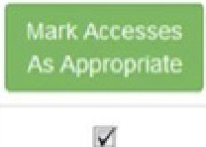
"i''°" '"""",'

!
E_ 4 14 6 See Ful Plol
••,.

Atyplcal access patterns are easily recognlzed

Expand graphs for addltlonal access detalls
200

O' '
01/01/2015 01/0512015 01/11/2015 01/17/2015 0112312015 01/3112015

- Mark accesses as appropriate by checking the boxes along the left and clicking the green"Mark Accesses as Appropriate" button.
- Use the search form to specify a Department, or search for variances during a specific time period via the"Analysis range" calendar. Click the blue"Submit" button after setting search criteria.

Creating Graphs
Click the"Create Graph" tab at the top of the Analytics & Reporting page to define your graph.

flri...._a....,.1cs Executive Reporting
Create Graph M,' Graphs Side-by-Side Graphs Patient Tlmeline Surfer Graphs Employee Variance

You can build your own graph for viewing accesses aggregated together by employees, departments, orany other data type in the system.

Defining Your Graph

Na:me• Test Graph_Trish
The narr-../d cription for your graph

Type of Graph

Group By•

Data Type to Count'
Standard Bar Graph
A Timeline Graph shows counts over time. but only compares at most severaI recorcls at a time Additionally. selecting of limeline recorcls is done when viewing the graph instead of defined on this page

Employee Info-> 'Oepartment"
Type of data to analyze (your x-ai<is variable).

Palienl lnfo->Palient Name
Type of data to count (i.e what's being counted on y-axs).

„ Is Unique
When enabled. the counts for each Group by type are of unique Counl type items only (e g if Group by !ype="Employee· and Count lype="Patient"', enabling means we counl the unique palients each employee has accessed, or if disabied, multiple accesses lo the same patient ara counted.

t) Maize Analytics 5

Name: The graph name will be displayed in lists and dropdown menus elsewhere in the system. Type of Graph: Choose bar graph or timeline. Bar graphs display more data at a time than timelines. Group By: x-axis variable
Data Type to Count: y-axis variable
Optional: Leaving the "Is Unique"box unchecked means multiple accesses to the same patient record will be counted separately and included in your graph. A in the box specifies the graph will display only unique accesses to patient records by employees.

Optional Data Selection
You can make a graph display a specific set of records using the "Optional Data Selection"form. Limit the x-axis values by choosing a data type in the "Select type"dropdown menu, and by listing specific records in the "Se/ect records"box. For example, graph a specific employee's accesses by selecting "Employee lnfo->Employee" and typing the employees name (e.g. Evil) in the Select records box.

Select type

Select records
Errployee lnlo->Department
Ił you want to restrict the graph to a partia.dar set of records select the type of these records

Enter the values of the Sefec:I. type records you want to restrict the graph to, separaling ITJ.Jltiple values by corr.-nas {e g if Selecf
Oncology. Pediatri
fyµe.:::"Department", you could enter '"'oncology, pe<liatrics"')

M-M-M-M- Click the blue"Create Graph" button. Your new graph is shown in blue. The displayed data are also available in table form by clicking the "Table"tab directly above the plot. Hovering over the graph or clicking hyperlinks in the table provides mare detail about accesses displayed.

Click the gray "Graph and Table Display Options" bar at the top of the page to select a specific date range to display, or to select a subset of the x-axis to display. You can switch to another graph using the "View Graph"dropdown menu in the upper right. Newly created graphs are listed at the bottom of the dropdown menu, under "My Graphs."

My New Gra h View Gmph: Sełecl a graph

- Graph and Table Display Opc,ons

Date range
01/02/2015 • 02/02/2015

Upload source• Upload•
All uploads All

Update Graph/Table

Rese1 GraphrTable

Oepartme11t to Highlight Choose... (O selected)

sys1■m Grapns
A.ccesses per Department Access.es. per Depanment TMTiellne Access.es per Empło)ee Tlmehne
.Accesses per ICO=V37 7 Pattenl Accesses per Oncology ErnplOyee Accesses per Patient
Accesses per Pauent T1mehne
Accesses per emplOyees e_148. e_394 e_526
counl or Accesses per Emp!O)ee ICDs an EmplOyee Accesses Patlents an Employee Accesse:s
-""'l' ,."'-'i..l r Oepartmenl
My Graphs
My NewGrapn

Once you've chosen your display options, click the blue "Update Graph/Table" to apply them.
t) Maize Analytics 6

